# Terms of reference (ToR) for the study on the social impacts of the EU ETS 2 in selected Member States

## Background

The success of the ETS 2 depends to a large extent on its acceptance by citizens across Member States. Key to this is the perceived social justice of the instrument and the availability of options to shift away from high-emission modes of transport and heating. As the instrument is new, a constructive debate on its further calibration will be important. To inform this debate, a study on the socio-economic impacts of higher fuel prices induced by the ETS 2 on private householdsin the EU and selected Member States will be commissioned, with focus on the CEE region. The study will use quantitative data analysis to assess the distributional impacts differentiated according to intensity of current use of fossil fuels in transport and heating and other variables. This study will form the basis for policy recommendations in the advocacy campaigns on both the ETS2 (e.g. in terms of the need for price stabilisation mechanisms) and the Social Climate Fund (e.g. in terms of the need for a higher volume of the fund or different allocation criteria). It will be disseminated within the European Commission and in the selected Member States and will be shared with selected Members of the European Parliament and presented towards governments in order to inform a constructive debate on how households can be supported in shifting away from high-carbon modes of transport and heating in a socially just manner.

## About the project

This work is part of the LIFE EFFECT project, financed by the LIFE Programme. This project aims to improve the knowledge, capacity and networking of civil society and other key actors on the issues related to the ETS2 and the Social Climate Fund (SCF), to inspire and enable them to engage with national and EU policy processes. These engagements will help ensure that national implementation of the EU ETS and the SCF occurs in a way that maximises the climate benefits by promoting rapid decarbonisation and secures social justice by protecting vulnerable households and leaving nobody behind. By doing so, the project will contribute to fair and effective carbon pricing policies.

## Scope of the study

### Social impact of EU ETS 2 from socio-geographical perspective:

The existing studies look at the EU ETS 2 impacts in the broad perspective, answering questions such as how much the household budgets will be affected by the rise of prices, or how it will differ between income groups and countries. These studies often assume an average consumption of fuels, e.g. 5 % of household expenditures for electricity, 4 % for heating, 2 % for fuels (see the figure below as an example of the Czech Republic), thus resulting in averaged impacts and underrepresenting the impacts on the most vulnerable groups. Focus on vulnerable groups differentiated by the fuel use, gas and coal dependency, carbon intensity of buildings and transport, renovation status, ownership structure, and rural vs urban contexts are less common. In this study, we aim to look into the social impacts of EU ETS 2 in more detail, concentrating on the most affected groups and locations.

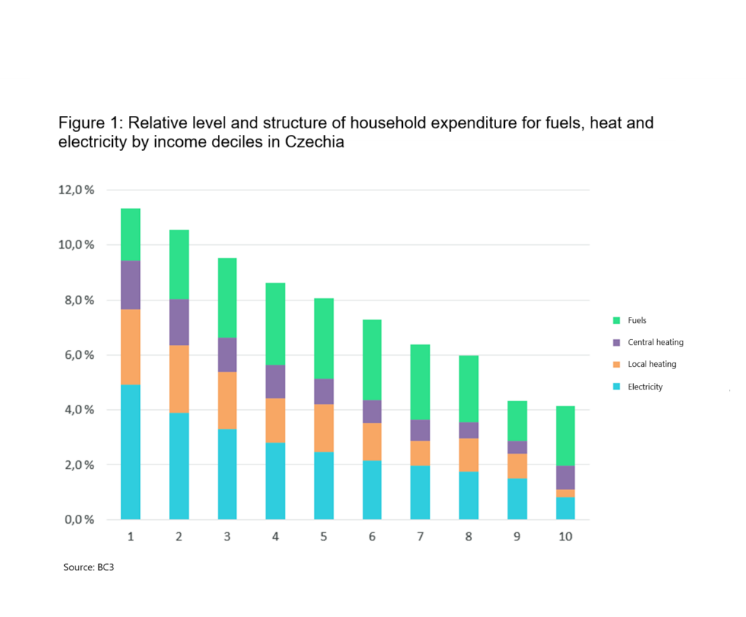

### Geographical focus:

While the study aims at comparing the selected EU Member States’’ vulnerabilities by using standard metrics, every country faces specific challenges within local contexts. The study will dive into the cases of three countries: Czech Republic, Poland and Slovakia/Bulgaria, countries that are the most vocal in raising concerns about the impacts of the EU ETS 2 on households, pushing for the postponement of its implementation or strengthening of price stabilisation mechanisms. Here, it is important to carefully consider the anticipated effect of EU ETS 2 and the policy options for moderating such effects through national measures as well as EU-based support measures for the CEE region.

### Relevance:

This is relevant for three reasons: first, the focus on vulnerability enables identifying beneficiaries of the Social Climate Fund (SCF) and creating tailored policies fitted to the needs of the key groups and regions. Second, it could inform the optimal redistribution of the fund and wider ETS2 revenue between income groups, which will all be affected in diverse manners, including the middle class. Third, given the geographical focus and the novel methodology, it could start a constructive debate on further calibration of the ETS2.

### Content:

* Looking into the household consumption data across countries (probably SILC) and comparing the vulnerability of households through selected lenses:
  + fuel use
  + gas and coal dependency
  + options for fuel substitution
  + carbon intensity of buildings and transport
  + renovation status
  + ownership structure
  + rural vs urban contexts

Analysing the relation between these variables and energy expenditure and linking it to the possible effects of EU ETS 2 allowance prices.

* Looking into the SCF allocation and analysing whether it offsets the regressive impact of EU ETS 2 between Western and Eastern MS.
* Looking specifically at the three selected Member States (Czech Republic, Poland and Slovakia/Bulgaria) and analysing the vulnerabilities at national level, using additional national datasets and perspectives on local contexts.
* Analysing the selected MS’s transport and buildings decarbonisation policies, mainly within NECPs, and projected emission pathways by 2027 in order to understand the possible effects of postponing the EU ETS 2 implementation, is one more year likely to make any difference in terms of protecting lower income groups if the policies in the NECP are implemented? If insufficient for managed decarbonisation, analysing possible complementary policies to lower emissions reductions in a socially inclusive manner (and stressing the need for stronger complementary policies).

### Main deliverables:

1. Report on the social impacts of the EU ETS 2 in selected Member States (est. 30-50 pages)
2. Written explanatory note of the methodology and process used to compile the report as well as the assumptions and required disclaimers
3. Support and review of the slide deck presenting the results prepared by AMO using graphs provided within the report
4. Availability of the lead author to present and discuss the results of the work during a public-facing event

## Related resources

[Can Polluter Pays policies be progressive?](https://ieep.eu/publications/can-polluter-pays-policies-be-progressive/) (IEEP, 2022) Note: differentiation between rural and urban households in the modelling

[Putting the ETS 2 and Social Climate Fund to Work](https://www.oeko.de/publikation/putting-the-ets-2-and-social-climate-fund-to-work/) (adelphi, Öko-Institut, Center for the Study of Democracy, WiseEuropa, 2023)

[Criteria for an effective and socially just EU ETS 2](https://foes.de/en-us/publications/publication?tx_foespublications_listpublications%5Baction%5D=show&tx_foespublications_listpublications%5Bbacklinkpage%5D=14&tx_foespublications_listpublications%5Bcontroller%5D=Publication&tx_foespublications_listpublications%5Bpublication%5D=285&cHash=4fe205417fd69f2add489b8b92960163) (FEST/FÖS, 2022)

## AMO’s contribution and follow up

Our aim is to use a data-driven approach to influence the debate around ETS2 and SCF. The report will be used within the advocacy efforts by AMO, CMW, CDE and partners throughout the LIFE EFFECT project around the 2026 revision of the ETS directive as well as related legislation.

## Budget

Not exceeding 15 000 € VAT included.

## Overview of the schedule and main deliverables:

| **Milestones and Deliverables** | **Notes** | **Timetable** |
| --- | --- | --- |
| Start of the contract | Signature of the contract. | T0 |
| Kick-off meeting | Agreement on the work programme and discussion regarding the objectives and approach. | T0 + 1 week |
| Implementation of Tasks as described above | Throughout the contracting period. AMO and CMW experts are available to provide feedback and additional information on an ongoing basis. |  |
| Full Draft Report | To be provided three weeks before the end of the contracting period. | T0 + 12 weeks |
| Feedback | Call with AMO and other LIFE Effect members to give feedback on the draft report. | T0 + 12 weeks |
| Integration of feedback and finalization of Report |  | T0 + 15 weeks |

Note that draft and/or partial deliverables (including interesting graphs or results) can be shared when ready to ensure they can be used by the LIFE Effect partners when politically relevant.

**Application Process**

Consultants wishing to express their interest in undertaking this work are requested to apply by submitting a proposal containing:

* Tasks consultant/s intend to undertake
* Methodology to be used in undertaking the tasks
* Time and activity schedule
* Overall budget, clearly identifying day rate and any other costs in EUR for the tasks covered
* Curriculum vitae of the consultant/s and evidence of relevant experience

The selected consultant/s will be expected to conduct the work within the budget and timeline agreed. Complete proposals should be no longer than 6 pages and submitted in pdf format to the following email address: kristina.zindulkova@amo.cz

The consultant/s can also indicate interest in the given email address in order to start a discussion on the specific requirements and possibilities for the task.

The deadline for submitting proposals is **12th of February 2025.**